A

Project report on

**“*SYNCHRONIZATION OF SOLAR AND MSEB”***

Submitted By

***Ms. RUCHA BHANGE (B120253015)***

***Mr. AKSHAY PATIL (B120253127)***

***Mr. ROBIN SINGH (B120253139)***

Guided By

**Mrs. M.P.SARDEY**

**Electronics and Telecommunication Engineering**

**SAVITRIBAI PHULE UNIVERSITY PUNE**

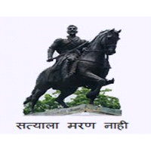

**ALL INDIA SHRI SHIVAJI MEMORIAL SOCIETY’S**

**INSTITUTE OF INFORMATION TECHNOLOGY, PUNE**

**ACADEMIC YEAR 2016-2017**